CLOUD COMPUTING

Mini-Project

**Phase I: -**

* Create a web application (any application) having a frontend (simple UI, not mandatory) and backend (api endpoints can be used) which also uses some database server to store the information or data persistently.
* A client can be a web browser, curl, postman, etc.
* The web app server can be written in any language and framework (e.g. Flask, Django, NodeJS etc.), and use any database server to store the data persistently in your database server as per the information is provided to the app.

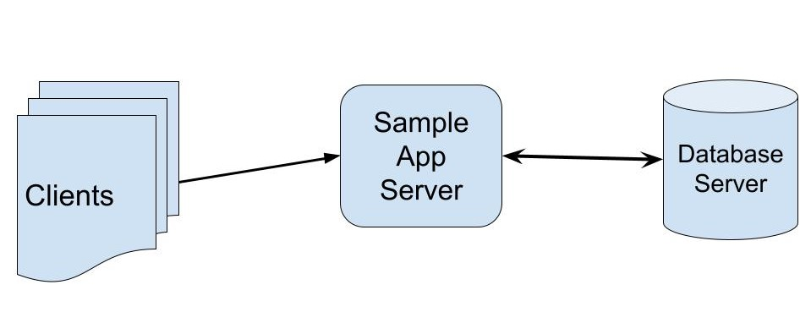

**Phase II: -**

* Deploy an architecture using following security practices to secure the Database server and web server, and also handle their management using a Bastion Host separately in a VPC.
* **Simplification: -** Only launch one instance for web server, and one instance for database server, and choose security groups as per the requirement.
* Implement such an architecture on any public cloud services. Generally, all the services used in this project comes under free-tier.
* Read the documentation carefully. Project can be done on any cloud provider.

*The architecture is not showing any bastion host. So decide it by yourself where to launch a bastion host so that it can be used to manage the web server and database server both. (Don’t use Bastion Host service, instead launch a separate instance to setup your Bastion Host).

**Sample Architecture**:-

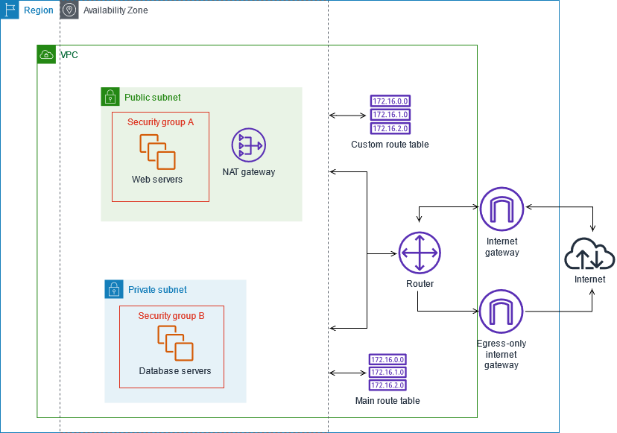

* **The report should mention all the steps in the form of screenshots and the challenges you faced while implementing the project and your approach to overcome.**

**Reference:-**

<https://docs.aws.amazon.com/vpc/latest/userguide/VPC_Scenario2.html>